Began involvement with project after approaching Josh Feinberg for opportunities to expand upon my prior experience with 3D modelling and manufacturing. The ultimate project goal is to inexpensively construct a Halbach array with the use of 3D printing and rare earth magnets that can be used to take measurements portably, perhaps in the field or some such similar setting. The Halbach array is notable in that the precise orientations given by a series of equations allows for a much stronger field to be produced than each individual magnet could produce on its own. Fields as strong as a tesla can be generated, and successive concentric rings can both add to this field as well as be rotated to a specified number of degrees to either add or subtract components from the produced field; thereby creating both a maximum and minimum field strength in addition. Therefore, design initially focused on the creation of a single ring of magnets, and once refined, a second ring was added to the design, with the ability to rotate the outer ring a total of 180 degrees around the inner ring of magnets.

**Design:**

Concept originally formed with inspiration from Raich and Blümer (2004), documenting their own pursuits in designing and constructing a Halbach array.

Began with a prototype given to me by Michael Volk.

* Began design with an arbitrary number of magnets, chose 8 to begin with
  + Shifted to 12 after the design for the first prototype became somewhat problematic with symmetry, as well as for the purpose of producing a stronger field
* In fine-tuning the design, a tolerance was found for the magnet wells, with a side length of 9.95 found to be a good balance between ensuring the secure fit of the magnets such that they would not slide out even when the mechanism was overturned and loose enough that it is still possible to remove individual magnets.
* In the style of the first protype, originally envisioned creating two printed, thin rings
  + Effectively, one ring had shallow wells into which the magnets could be set, and a second, matching ring would be placed over the top, sandwiching the magnets between the two sets of rings.
  + This design was found to be unsuitable, as the strength of the magnets is such that it was virtually impossible to maintain the exacting fit desired and be able to place the magnets into the housing in the proper orientations.
* From there, switched into a single ring-design, where the depth of the wells was such that the magnets could be slid into the housing and prevented from shifting during the placement of surrounding magnets.
* Once the design of the first, inner ring was finalized, the outer ring was designed to fit snugly to the inner ring, with the greatest emplacement of magnets
  + More magnets= a stronger field

**Inner Ring Prototypes**

1. First attempt at a print, 8 magnets, and distorted model in Cura- printed with no center hole
2. Switched to 12 magnets, added pinholes in bottoms of each magnet well to ease removal
3. Smaller magnet wells, closer together. Changed total diameter to current value. Larger diameter for the pinholes
4. Added mark on bottom to indicate field direction- shallow- began testing ideal height for magnet emplacement
5. Added mark on top as well, taller ring
6. Taller ring, 10mm?
7. Tallest ring, present configuration
8. **Added a component used for the turning mechanism created with the outer ring**
9. Adjusted the fiducial mark to line up with both the component as well as the markings along the outer ring
10. Somewhere around here, it was discovered that google drive, used for transferring files between computers

**Outer Ring Prototypes**

1. First design of outer ring, partial print. No holes for magnet removal
2. Added pinholes- gradual marks at 5 and 10 degrees.
3. Removed pinholes along groove, drilling planned instead for smoother groove surface for mechanism. Adjusted mark widths to print more clearly. High detail
4. Fixed erroneous marking placement, added additional length to grooves to compensate for thickness of turning protrusion.

**Other Components:**

1. Created a cover for the inner ring
   1. Split into two due to invalid model configurations
      1. First, smaller half of the cover printed, lifted from print bed and curved
      2. Reprinted smaller cover half with brim to ensure good adhesion to print bed
      3. Printed larger cover half with brim as well
         1. Removed brim and sanded for smooth effect
2. Created a back cover for the inner ring/outer ring assembly
   1. High detail, includes a inset for the turning component of inner ring as well as ridged edges for both gripping purposes as well as distinction from the outer ring while turning mechanism

**Testing:**

Initial testing of field strength began on the first “inner” ring of 12 magnets.

As three varieties of hall probe were utilized to measure the produced field, three “holders” were laser cut in order to match the specifications of each probe, as well as to be able to fit closely within the center of the ring to minimize error produced from minute shifting of the grid formed by the holders. This static holder, with known spacing for measurements, allowed for measurements to be plotted onto a grid, resulting in three-dimensional coordinates.

The first measurements were made with an axial hall probe, and are shown in the figure below:

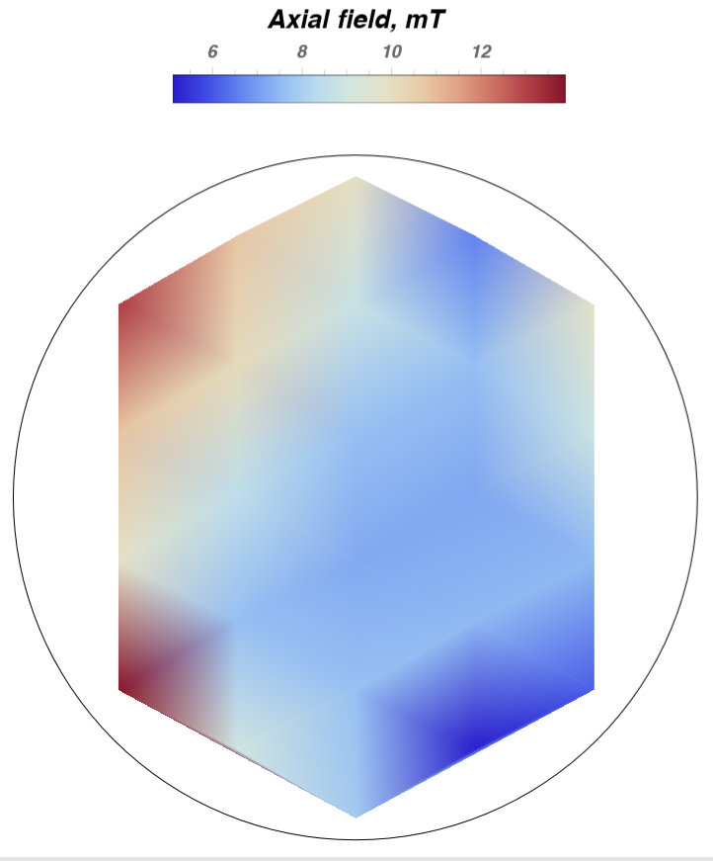This data is less than ideal, as well as the following initial transverse data and stricter, more rigorous testing commenced. Additionally, the construction of the third laser cut holder is less than ideal, preventing proper fit of the smaller transverse probe. The lakeshore probe was borrowed to another lab and is thus unavailable. Therefore, the slightly larger holder intended for the lakeshore probe was used instead, introducing a small component of error due to the slight size mismatch between probe and laser cutter tolerance.

Greater emphasis was placed on understanding and properly utilizing the transverse hall probe before working with it, and tentatively, designing and printing a suitable tall, rigid frame with which to minimize adjustment of the probe during measurement. Additional care is required in ensuring the correct orientation of the holder in regards to the orientations of the ring.

It was found that the probe takes measurements perpendicular to the widest edge of the probe. In addition, the probe also is negative on the side with the logo. Therefore, measurements should be carefully ensured that they are taken with a single orientation.

Individual magnets were tested with the use of another 3D printed apparatus. This was designed to both hold a single magnet, with a slot positioned a know distance from the edge of the magnet. This was intended to measure the strength of the magnetic field produced along each face; this is in hopes of getting both a sense of the magnetic field around the magnets, as well as determining the differences between different magnets.

Additionally, of note is the fact that the plot of the data is such that individual data points do tend to stand out when characterizing the nature of the magnetic field produced within the ring. As seen above, data points can be seen. It is somewhat less obvious in this plot than in the plots with the transverse data. There is some hope that this issue will partially resolve itself with the advent of more rigorously gathered data.